
CORNWALL RURAL HOUSING ASSOCIATION
CRHA’s development at Kew Pendra St Buryan

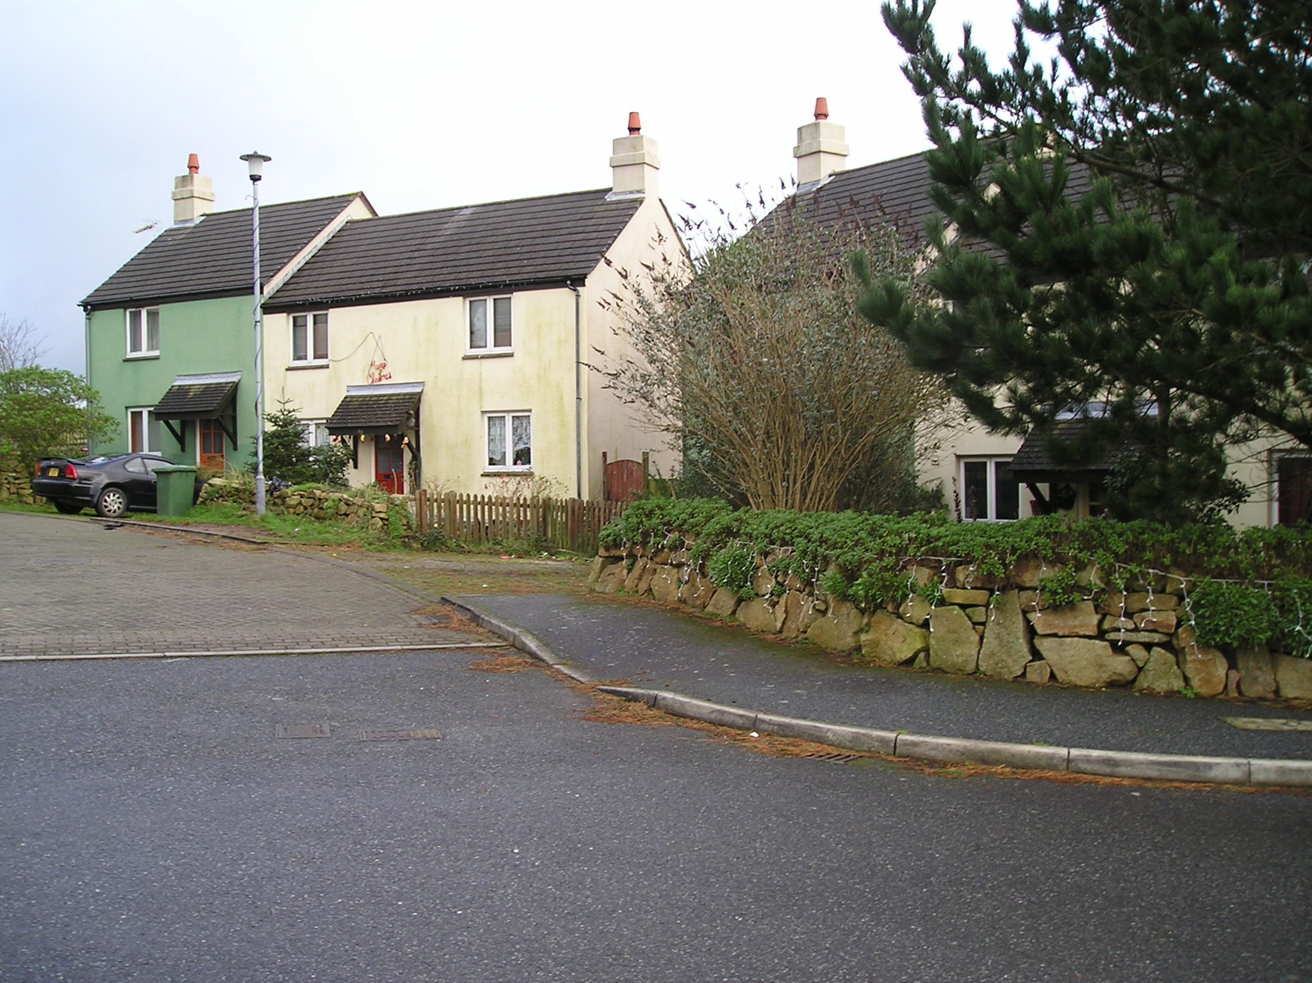

A two bedroom house (maximum 3 persons) will shortly become available for letting on the above development.
Rent £124.13 per week.

2 Bedrooms, Bathroom, Electric night storage heaters, Fitted Kitchen
and Own Garden and Parking Available.

Applicants wishing to be considered for this property must have a strong local connection with the Parish of St Buryan.

The property will be advertised between 3rd July 2024 to 29th July 2024

Cornwall Rural Housing Association Ltd.
19 Callywith Gate
Launceston Road
Bodmin
PL31 2RQ

Tel. 01208 264530
E-mail info@crha.org.uk

