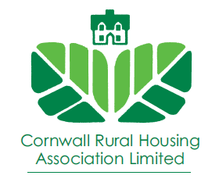

FOR SALE
£75,000 for a 25% Share
The Triangle, The Lizard, Helston TR12 7FA
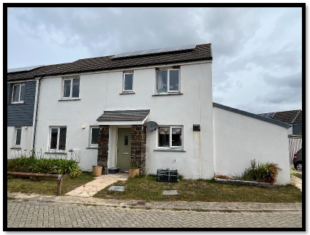

This property is subject to a Section 106 Agreement, which means applicants will need to demonstrate a strong local connection to the Parish of Landewednack. There is a staircasing cap of 80% with CRHA always retaining 20%. The minimum purchase share for this property is 25% of the market value.

12 The Triangle is a 4 bedroomed house on development at The Lizard.
To the ground floor there is a kitchen/dining room (6.03m x 2.75m) with fitted kitchen with access to, lounge (6.03m x 3.49m), cloakroom/w.c. and hallway.
To the first floor there is four bedrooms (bedroom one 3.50m x 3.02m, bedroom two 3.50m x 2.90m, bedroom three 3.01m x 2.76m, bedroom four 2.89m x 2.76m) and a bathroom/w.c. including an over bath electric shower.

Lounge
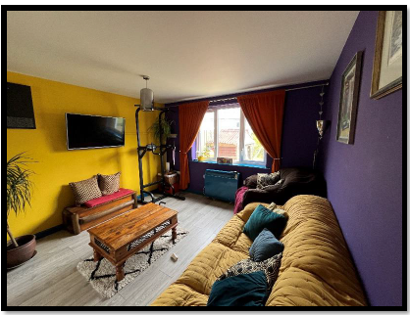

Outside there is a turfed garden area to the front, a turfed private rear garden and a porch giving access to an external store.
The property has its own two parking spaces located to the side of the property and gated access to the rear garden.
The property has been built to high insulation standards with uPVC double glazing and has an electric heating and hot water system, with night storage heaters fitted to all principal rooms. The property has been fitted with five solar photovoltaic panels.
Dining Area

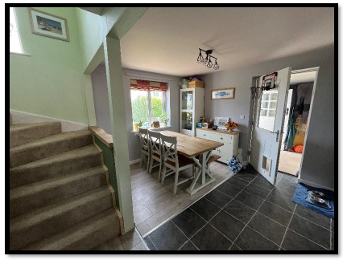
Rear Garden and Parking Allocation

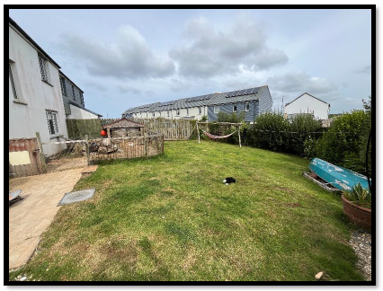

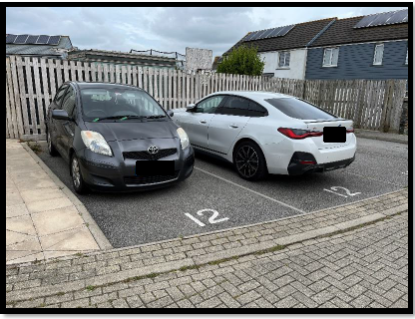

Kitchen

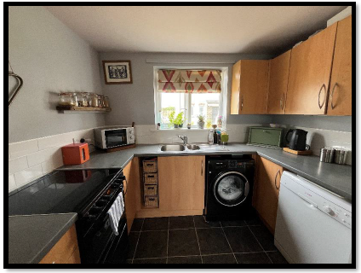

Shared Ownership:

The 25% share is available at the purchase price of £75,000. The remaining 75% is owned by Cornwall Rural Housing Association and has a rent and service charge payable to them.

The monthly rent payable is approx £495.78 (to be confirmed).

The service charge (covers building insurance and admin charge) £12.60

The length of the lease is 92 years as from 17th August 2024.

Viewing: To arrange a viewing please call on 01208 892000.

These particulars are prepared for the guidance only of prospective purchasers. They are intended to give a fair and overall description of the property and do not constitute the whole or any part of an offer or contract. The information contained herein is given in good faith but should not be relied upon as being a statement or representation of fact. Please note shared owners are fully responsible for the repair and maintenance of their properties and are sold as seen. Purchasers will therefore need to undertake all relevant checks prior to their purchase to ensure that they pick up any potential issues prior to completion.

