
CORNWALL RURAL HOUSING ASSOCIATION
Percy’s Meadow, Blisland

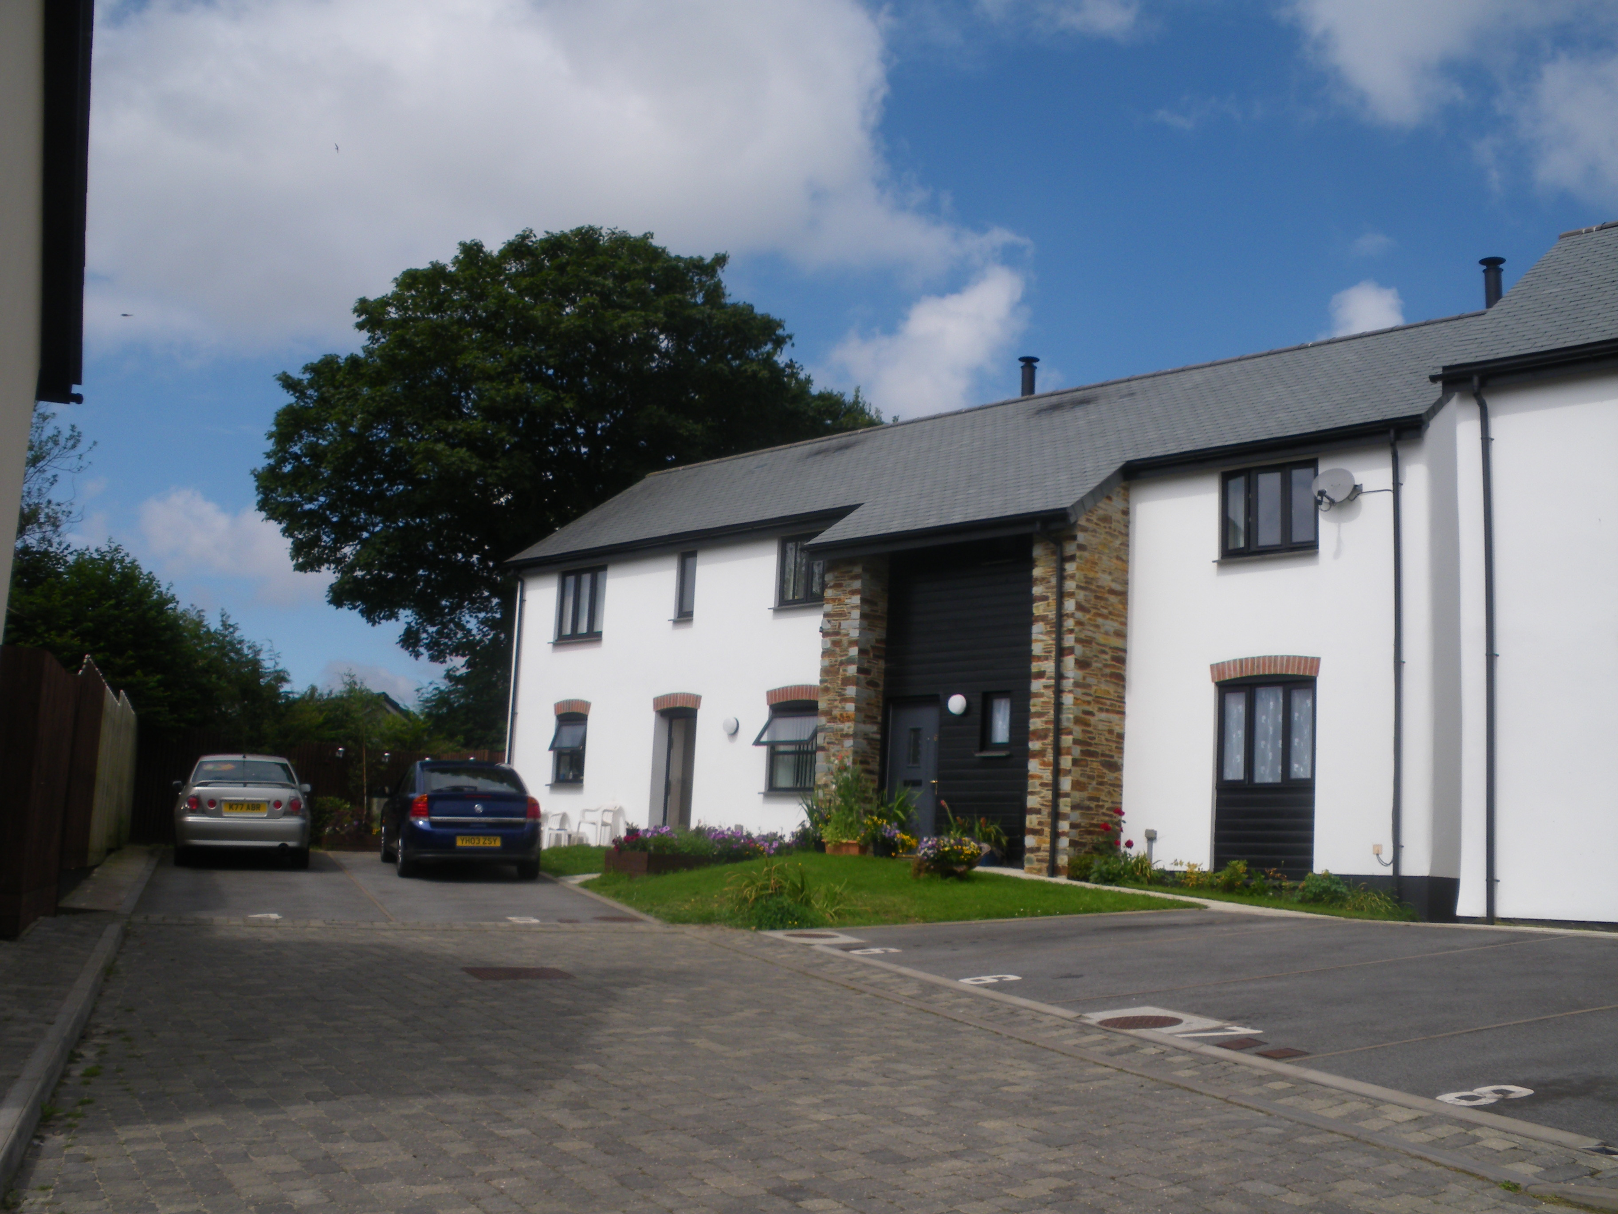

A two bedroom ground floor flat with small rear garden and one allocated parking space will shortly become available for letting on the above development.

Priority will be given in the first instance to single people and couples without children and or require level access accommodation. If there are no suitable applicants we will consider applications from 3 person (max) households.

The rent on the property will be approx. £114.58 per week

Applicants interested in being considered for this property must have a strong local connection with the Parish of Blisland in the first instance. Applicants may also be considered if they have a connection to the parishes of Cardinham, Helland, St Mabyn, St Tudy, St Breward and Altarnun.

Applicants must complete an application form, either call our office on 01208 892000 or complete online https://crha.org.uk/forms/applications

Closing date for applications 20 December 2024

Cornwall Rural Housing Association Ltd.
19 Callywith Gate
Launceston Road
Bodmin
PL31 2RQ
Tel. 01208 892000
E-mail info@crha.org.uk

