

CORNWALL RURAL HOUSING ASSOCIATION
CRHA’s development at Polglist, Foxhole

A one bedroom bungalow will shortly become available for letting on the above development.

The rent on the property will be approx. £91.21 per week

Suitable for 2 persons (max) with priority given in the first instance to those that require level access accommodation. The property has electric night storage heating, lounge, kitchen and bathroom, front and back garden and allocated parking space.

Applicants interested in being considered for this property must have a strong local connection with the Parish of St Stephen in Brannel in the first instance. Applicants may also be considered if they have a connection to the parishes of Roche, St Dennis, Treverbyn, St Mewan, Grampound with Creed, St Enoder

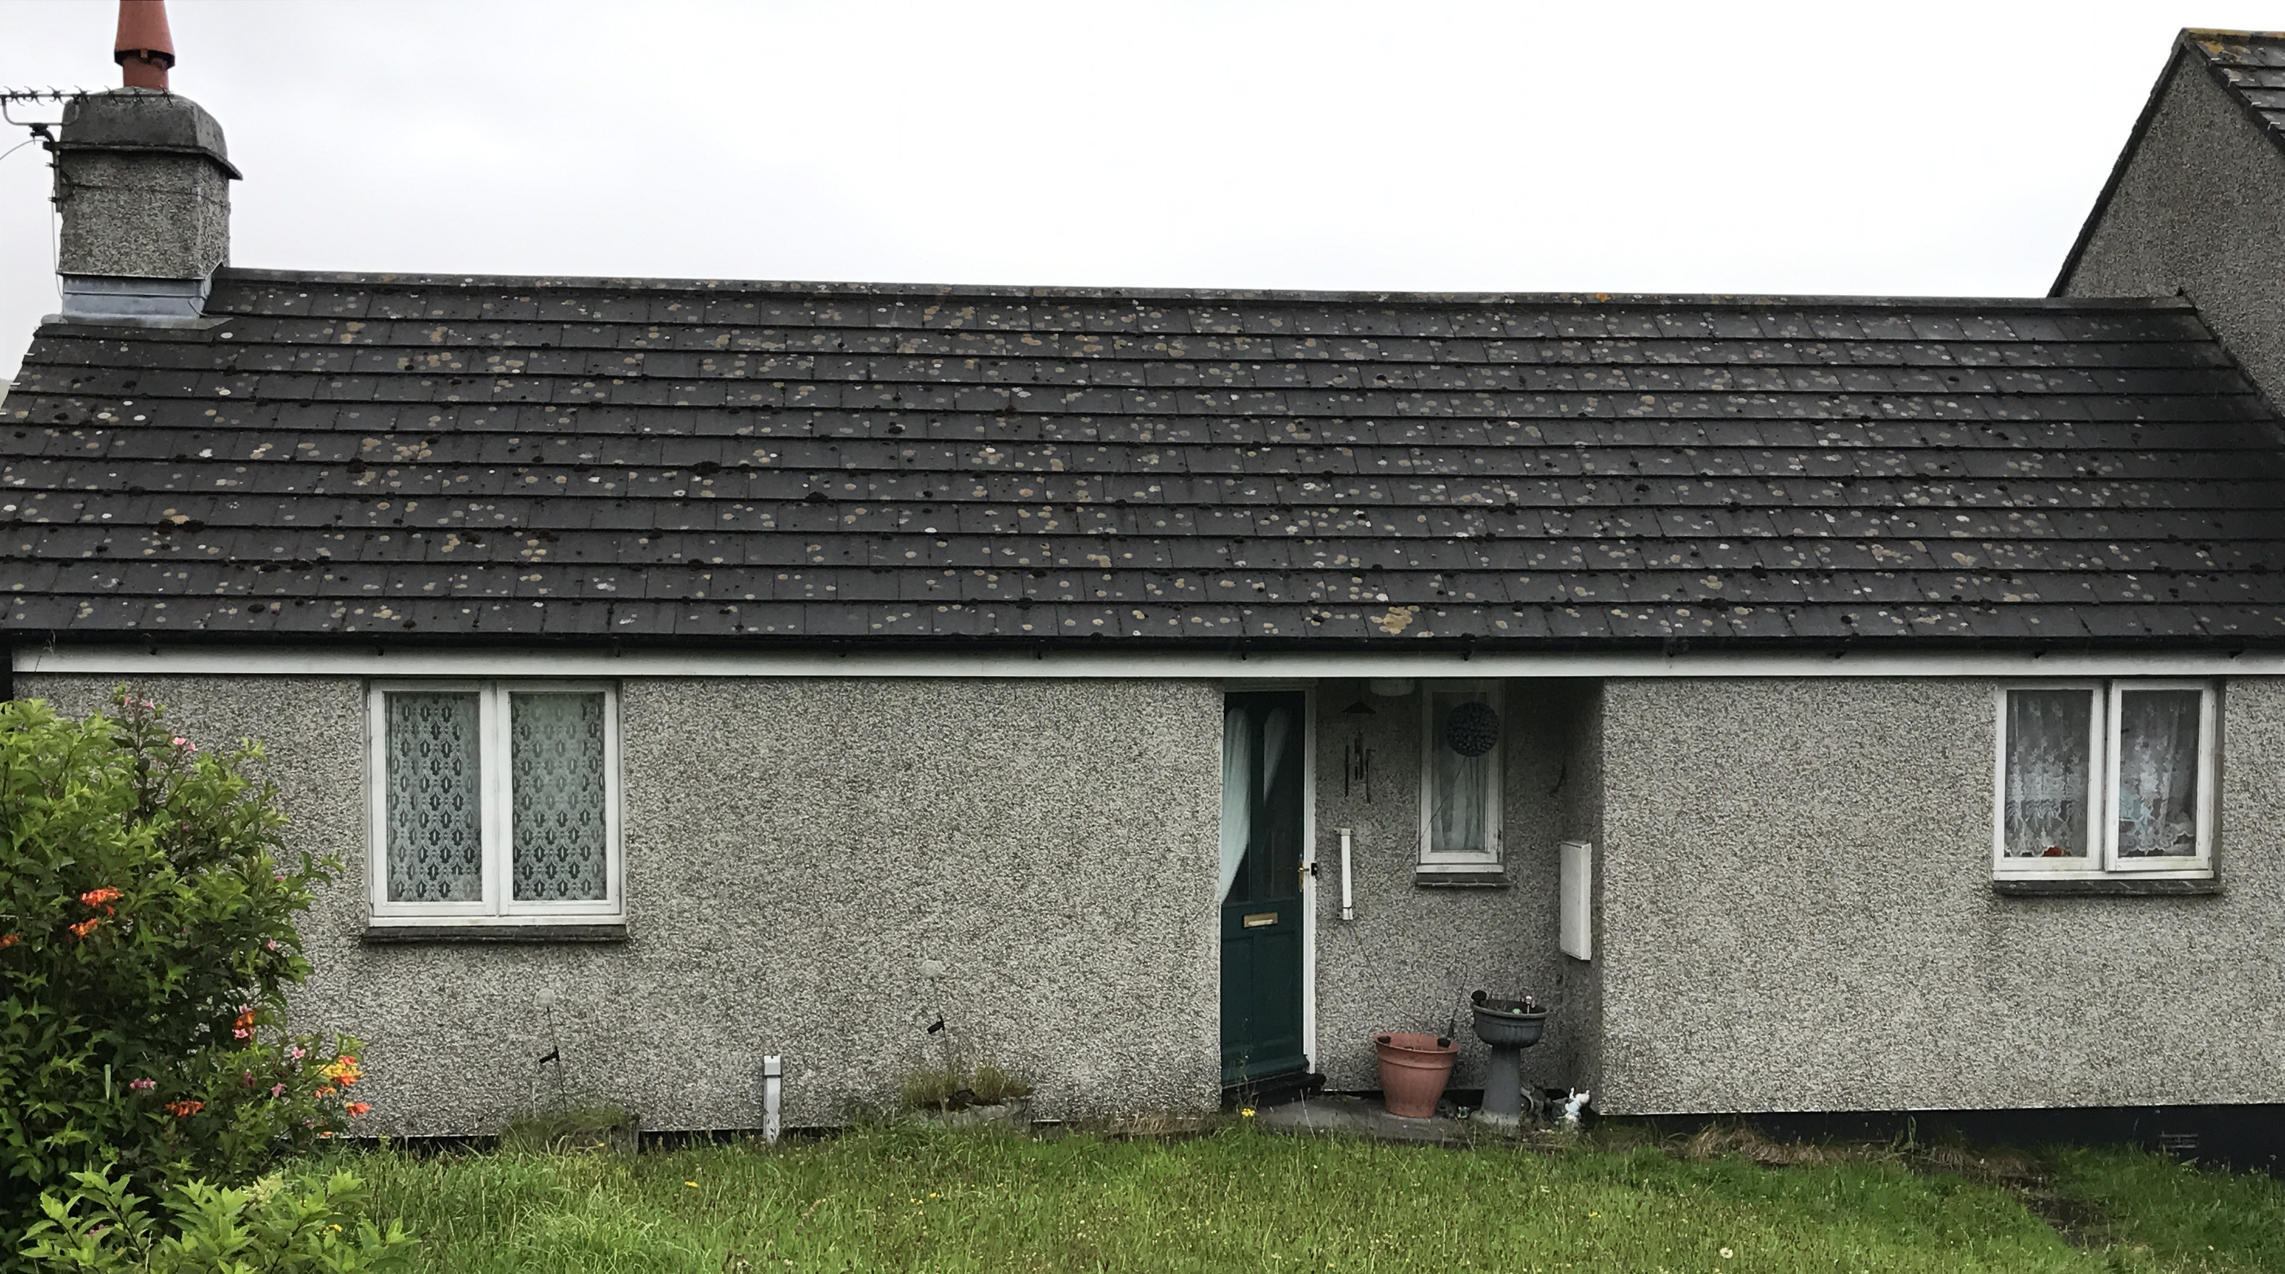

Applicants must complete an application form, either call our office on 01208 892000 or complete online https://crha.org.uk/forms/applications

Closing date for applications 20 January 2025

Cornwall Rural Housing Association Ltd.
19 Callywith Gate
Launceston Road
Bodmin
PL31 2RQ
Tel. 01208 892000
E-mail info@crha.org.uk

