
CORNWALL RURAL HOUSING ASSOCIATION
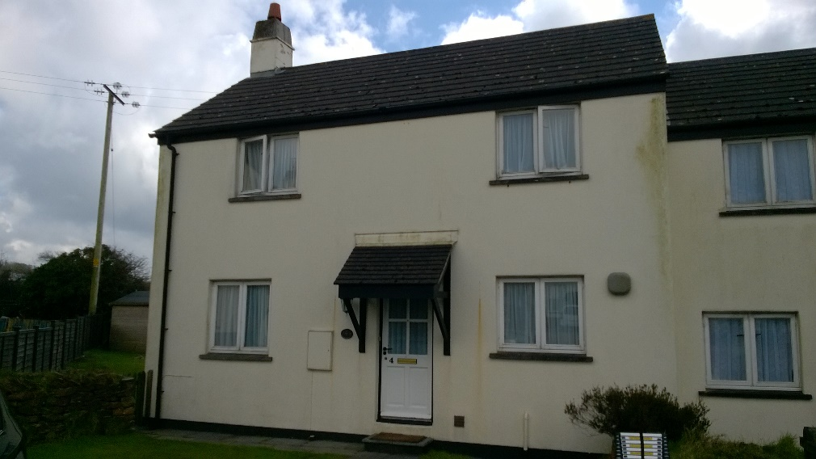

Harmony Meadow, Roche
A 3 bedroom 5 person end terrace house will shortly become available for letting on the above development.
The property has night storage heaters, own garden and off road parking. The rent on the property will be £142.61 per week.
Preference will be given to applicants with a local connection to the parish of Roche.
Closing date for applications will be Wednesday 18th June 2025.
To request an application please contact - Cornwall Rural Housing Association Ltd.
19 Callywith Gate, Launceston Road, Bodmin PL31 2RQ
Tel. 01208 892000
E-mail info@crha.org.uk

Cornwall Rural Housing Association Ltd. is a registered society under the Co-operative
and Community Benefit Societies Act 2014 (Registered Number: 24935R).

