
Cornwall Rural Housing Association Limited

Compensation Policy

1.0 Policy Statement

1.1 Cornwall Rural Housing Association Limited (CRHA) strives to provide good quality housing and services to all of its customers. However, it recognises that there will be instances where CRHA have not met its standards of service and customers may be inconvenienced or suffer a loss as a result. In such circumstances customers may be offered compensation as a form of redress for the failure in line with this policy.

1.2 This policy details the circumstances under which compensation will be considered by CRHA and the process for determining any amount of financial or non-financial compensation offered.

1.3 The compensation policy provides customers, team members and key stakeholders with an overview of CRHA’s approach to compensation. Compensation claims may form part of a formal complaint and are supported by clear compensation procedures.

1.4 CRHA will aim to restore a person/s to the position that they would have been in had a service failure by CRHA not occurred.

1.5 Any compensation payments made by CRHA will be fair and proportionate, with each case being considered on its individual merits. CRHA will apply discretion and common sense to the decision-making process while also promoting consistency.

1.6 Responsibility will be taken for any detriment or damaged caused to an individual or their property and belongings by a third party (contractor) working on CRHA’s behalf.

1.7 Compensation under this policy is defined as either:-

- A financial settlement or reimbursement in lieu of a clear, definable and measurable loss, or;
- A financial payment or an offer of something tangible as an apology for any inconvenience incurred.

2.0 Circumstances in which compensation will be issued

2.1 CRHA recognises three separate categories of circumstances where compensation may be paid and these are as follows:-

Mandatory

Examples of circumstances of mandatory payments include home loss, disturbance, improvements and payments under the Right to Repair scheme.

Quantifiable loss payments

This is where people can demonstrate actual loss. Examples of quantifiable loss include heating bills due to disrepair, having to pay for alternative accommodation or take away food, payment for cleaning or carrying out repairs where CRHA has failed to meet its obligations. Any claims for compensating quantifiable loss will only be considered where any such costs have been reasonably incurred and evidence of such loss can be provided.

Discretionary payments

CRHA may compensate people for time and trouble or distress and inconvenience caused by a failure of our service. Examples of where discretionary payments are applicable which include:-

- Poor complaint handling
- Delays in providing a service e.g. in undertaking a repair
- Failure to provide a service that has been charged for
- Temporary loss of amenity
- Loss of use of part of the property
- Failure to follow policy and procedure
- Unreasonable time taken to resolve a situation

2.2 CRHA does not regard financial compensation as the only method of remedying a complaint. We will consider whether other actions may be more appropriate, such as practical action, this could be offering to undertake repairs or redecoration which would otherwise be a customer’s responsibility or gestures of goodwill (e.g. vouchers, chocolates, flowers, decorating packs). Other remedies may be considered instead of or in addition to financial compensation and CRHA will adopt a flexible approach to considering different remedy solutions.

3.0 How will compensation be calculated?

3.1 The amount of compensation awarded will fall into line with the circumstances in which the compensation is issued. Each case will be considered on its merits and the impact the service failure has had on the individual/s, and these will fall into three separate categories ‘minor’, ‘moderate’ or and ‘severe’. Examples could include the following:-

- The extent to which the customers has suffered actual financial loss. The customer has borne additional costs due to the service failure.
- The extent to which the customer has been inconvenienced by the situation.
- The customers’ time and trouble in dealing with the service failure.
- The degree of disruption to the household, both physical and mental.
- Recognition of any failure by CRHA to follow policies and procedures.
- Any failures to follow the complaint handling process.

Other factors taken into consideration will include the duration of the problem and extent
or severity of the service failure. Further considerations will reflect on vulnerabilities i.e. any impact is worsened through disability, old age or the presence of young children.

3.2 CRHA will offer compensation if a customer suffers a loss of the use of a room or complete or partial loss of an amenity such as heating, hot water, power and lighting.

3.3 Compensation will be calculated with reference to the weekly rent for the property,
calculated as follows:-
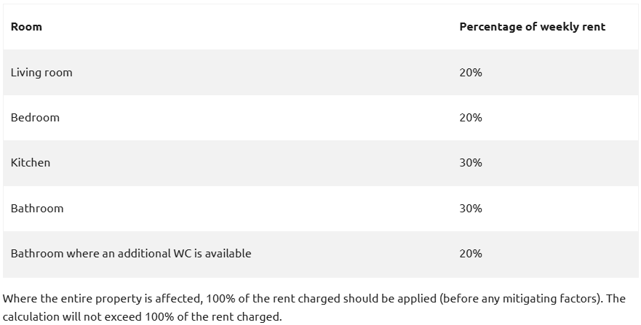

  - Where a customer suffers complete loss of the main heating system and hot water the compensation will be calculated as follows:

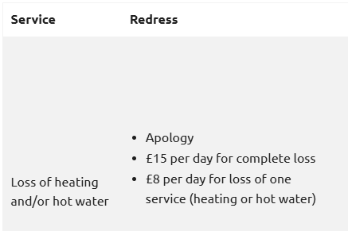
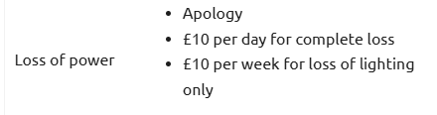

- Where the use of a room is substantially impaired (unable to be used for its intended purpose), compensation will be based as per 3.3 above.
- Compensation for loss of heating will not be made where suitable, alternative heating is supplied.
- Compensation will be calculated after the end of the applicable repair timeframe.
- Where a loss of power also affects heating and/or hot water provision, compensation will be awarded for both loss of power and heating and/or hot water.

3.5 All claims for compensation must be received in writing together with the provision of receipts and/or evidence to support the claim.

3.6 The amount of compensation will be proposed by the Property Services Manager and/or the Tenancy Management Officer and then agreed with the Head of Homes and Customers. Consideration will be given at that stage as to whether a payment should be altered to take account of the severity of any service failure and associated impact.

4.0 Situations where compensation will not be considered

4.1 Compensation will not be considered in the following circumstances:-

- Claims for personal injury
- Claims for damage caused by circumstances beyond CRHA’s control (e.g. through storm or flooding)
- Problems caused by a third party not working for CRHA
- Problems resulting from habitation use
- Instances where any damaged is covered under contents insurance. However, where damage has been caused directly as a result of the actions or omissions of CRHA or a contractor working on our behalf, consideration will be given to reimbursement without the need for the customer to make a claim at further inconvenience and cost to themselves, and in particular, where the facts are not in dispute.

5.0 Apology

5.1 Any offer of compensation made by CRHA will be accompanied by:-

- An apology
- An explanation as to how the failures in service occurred
- A demonstration of learning and a commitment to making service improvements

6.0 Payment

6.1 Compensation will normally be paid by cheque or bank transfer.

6.2 Where a customer’s rent account is in arrears, or has not been paid in advance in line with their tenancy agreement, the compensation payment will be credited to the customer’s rent account.

6.3 Where a customer owes outstanding sundry debt to CRHA, the payment of compensation will be off-set against what is owed.

7.0 Appeal

7.1 If a customer is not satisfied with the amount of compensation they may ask for the award to be reconsidered by the Chief Executive.

8.0 Monitoring and Review

8.1 The compensation policy will be reviewed every three years, or more often if required.

8.2 A report stating the amounts paid in compensation will be submitted to the Board
annually.

Date Reviewed | Changes to the Policy | Date to be Reviewed | Approved By | Author
Mar 2026 | The policy has been reviewed and the following changes have been made made to reflect and align this policy with the latest guidance releseased by the Housing Obudsman.  Sections 3.3 and 3.4 regarding compensation calculations and compensation criteria have been amended and expanded to reflect the latest housing ombudsman guidance. The previous method of calculating compensation payments has been deleted and replaced. | Mar 2029 | The Board | SA

To be reviewed March 2029

